Inventory Management System –

The system include the following sections:

1. Sales
2. Product
3. Price Levels
4. Clients
5. Returns
6. Reports

Sales – Log file of the outgoing movements.

Product – Products table – hold the information of each product ( amount,price…)

Price Levels – correspond to users type. (for example User type A get discount of 25 precent).

Users – Table of users that log in to the system and make the actions

Clients – specific user type that can buy\take items.

Returns – Section for return items by clients

Reports – Inventory Amount,Sales Reports,Charts…

Example of charts:

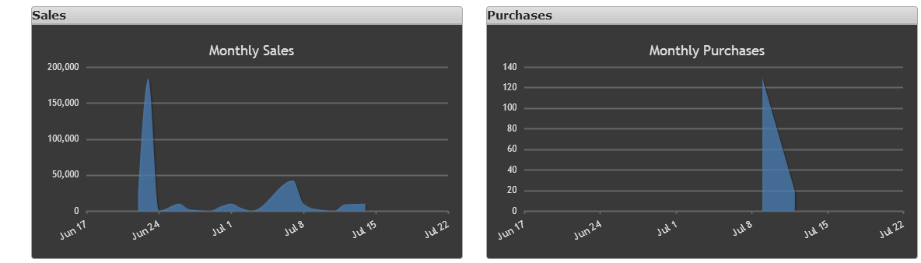

System need to be responsive.